Lab-Test

Student id: 1291822

1.

b) For all the values of x1, the sequences converge to zero.

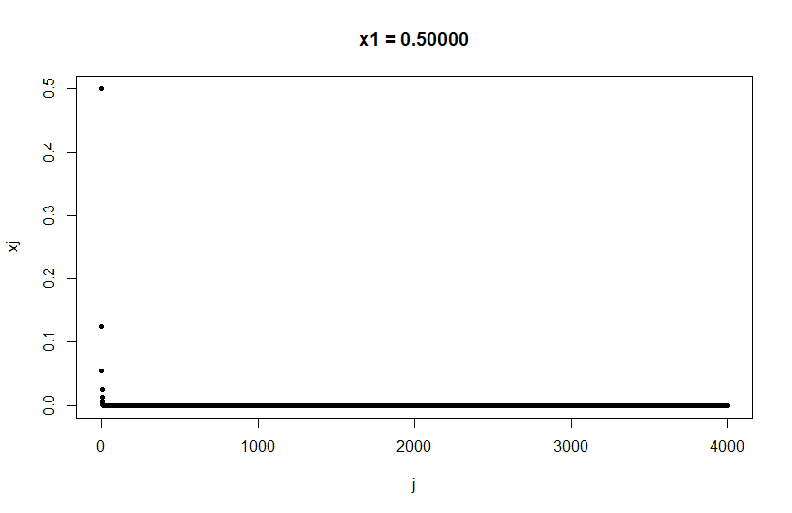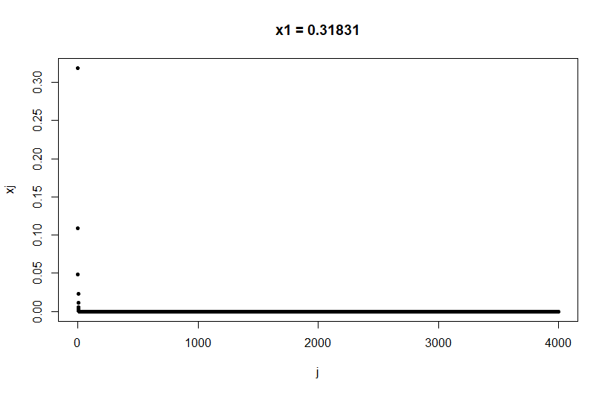

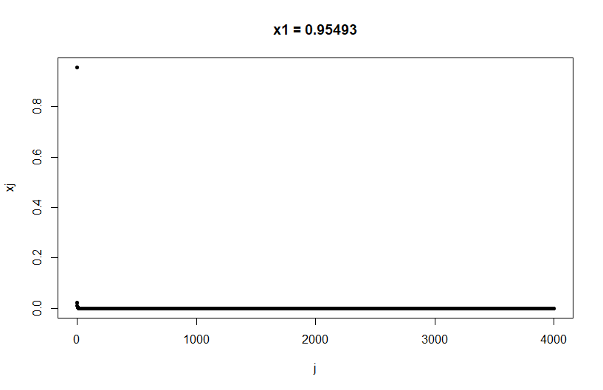

The plots show that the sequence converges to zero very quickly.

c) For r=3, the sequences seem to converge to a different point while also oscillating.

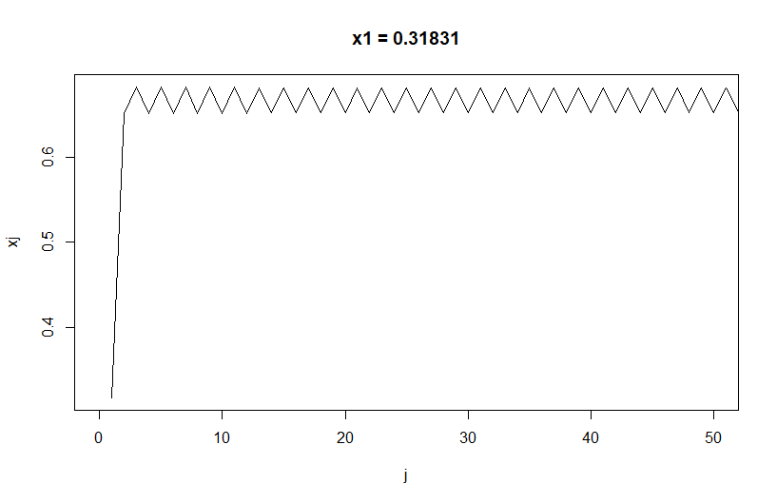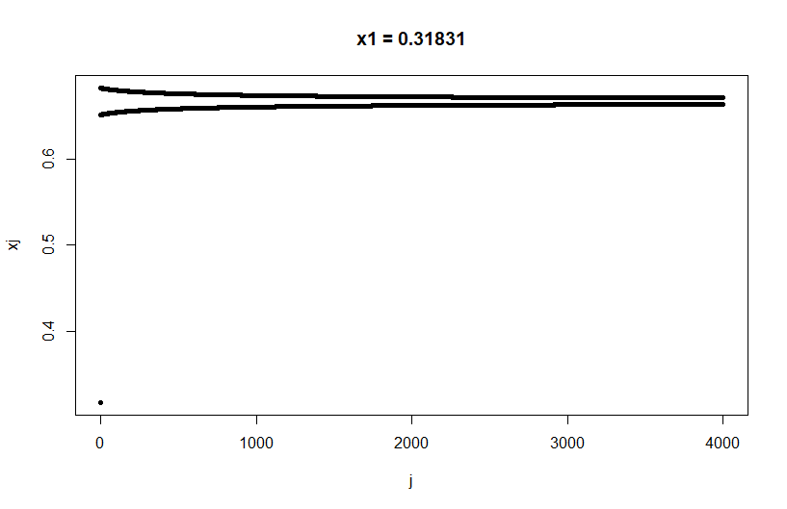

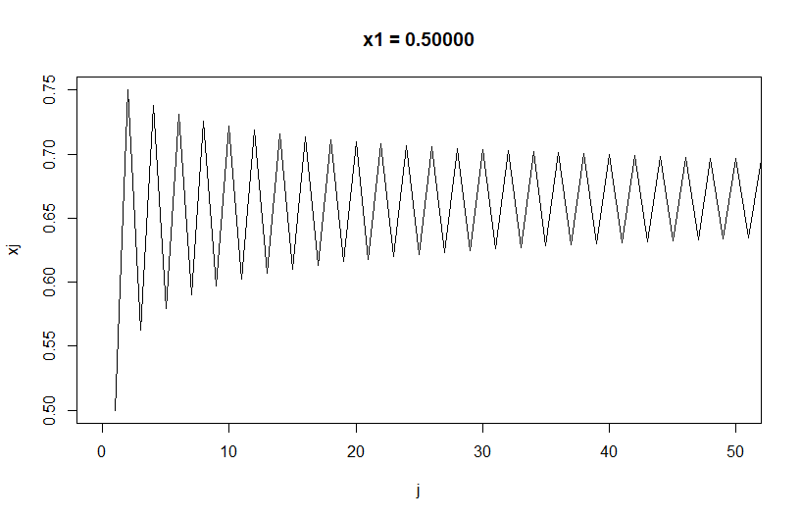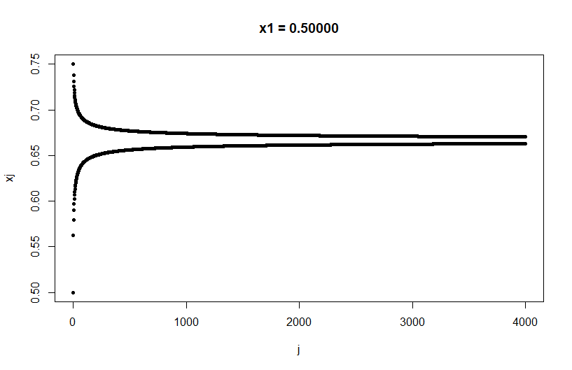

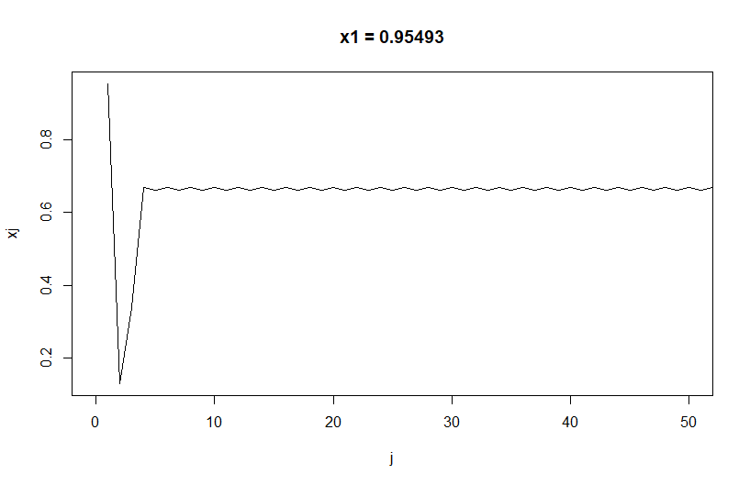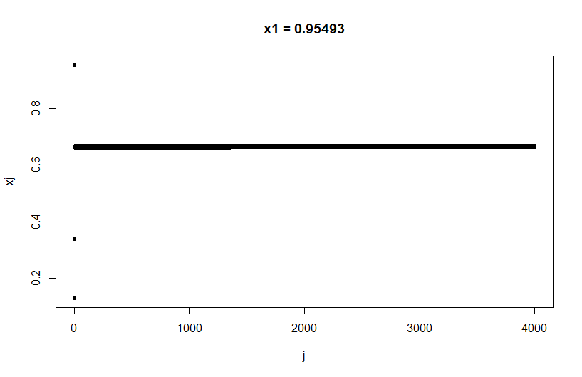

The sequence is called a logistic map and for values r>3.5, the sequence seems to show chaotic behaviour.

2.

a) Used the algorithm given in the lecture slides, full implementation in R-code.

# Generating one sample (repeat 100000 times for the question given).

U ~ U (0,1)

X <- 0

while (F(X) < U) {X <- X + 1}

Using sample function would be faster if allowed to be used.

b) Mean=1.99993

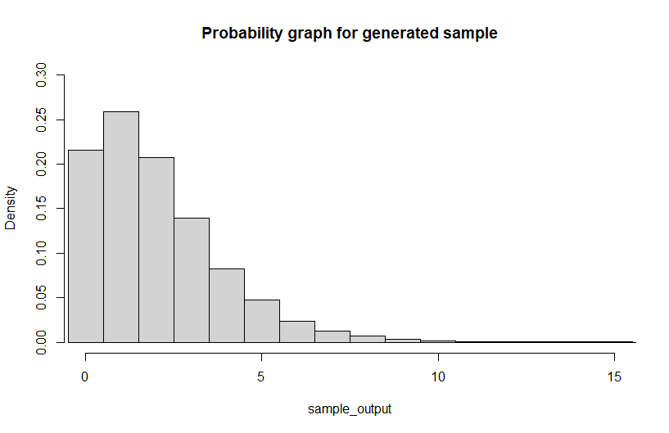

c) P values from i =0 to 10 are given below in order.

0.21604, 0.25849, 0.20757, 0.13917, 0.08278, 0.04725, 0.02347, 0.01273, 0.00665, 0.00302, 0.00140

3.

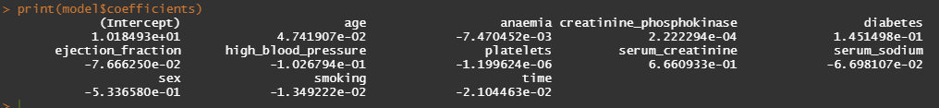a)

Residual deviance: 219.55 on 286 degrees of freedom.

b) For interaction between diabetes and serum_creatinine.

Residual deviance: 217.91 on 285 degrees of freedom.

c) Deviance difference in two models will follow chi-square distribution with df=1.

We get test-statistic=1.6421, p-value=0.20032. Since the p-value is large enough, we can ignore the interaction term and choose common slope.

d) Significant parameters: age, ejection_fraction, serum_creatinine, serum_sodium, time.

e) probability of death = 0.62538, eta = 0.51245

f) Here false negative means prediction is one (i.e., person has died) while true value is zero (person is alive). False -ve rate = 0.03448.